ST. JOHN LUTHERAN CHURCH BARTLETT, TX
ELW Setting Four - Sunday, April 21, 2024
Fourth Sunday of Easter

Announcements
Prelude

Thanksgiving for Baptism (ELW p. 97)
In the name of the Father,
and of the ☩ Son,
and of the Holy Spirit.
Amen.

Joined to Christ in the waters of baptism,
we are clothed with God's mercy and forgiveness.
Let us give thanks for the gift of baptism.

We give you thanks, O God,
for in the beginning your Spirit moved over the waters
and by your Word you created the world,
calling forth life in which you took delight.

Through the waters of the flood you delivered Noah and his family.
Through the sea you led your people Israel from slavery into freedom.
At the river your Son was baptized by John and anointed with the Holy Spirit.
By water and your Word you claim us as daughters and sons,
making us heirs of your promise and servants of all.

We praise you for the gift of water that sustains life,
and above all we praise you for the gift of new life in Jesus Christ.
Shower us with your Spirit,
and renew our lives with your forgiveness, grace, and love.

To you be given honor and praise
through Jesus Christ our Lord
in the unity of the Holy Spirit, now and forever.
Amen.

Gathering Song - Now All the Vault of Heaven Resounds - ELW Hymn #367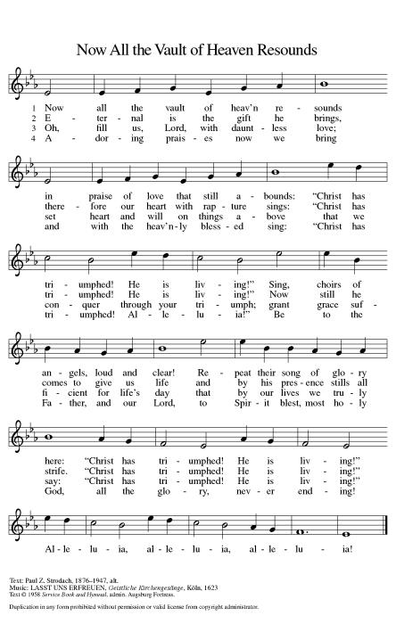

Greeting (ELW p. 147)
The grace of our Lord Jesus Christ, the love of God,
and the communion of the Holy Spirit be with you all.
And also with you.

Kyrie (ELW p. 147)
In peace, let us pray to the Lord.
Lord, have mercy.
For the peace from above,
and for our salvation,
let us pray to the Lord.
Lord, have mercy.
For the peace of the whole world,
for the well-being of the Church of God,
and for the unity of all,
let us pray to the Lord.
Lord, have mercy.
For this holy house,
and for all who offer here their worship and praise,
let us pray to the Lord.
Lord, have mercy.
Help, save, comfort, and defend us, gracious Lord.
Amen.

Canticle of Praise (ELW p. 148)
This is the feast of victory for our God. Alleluia.
Worthy is Christ, the Lamb who was slain,
whose blood set us free to be people of God.
Power and riches and wisdom and strength,
and honor and blessing and glory are his.
This is the feast of victory for our God. Alleluia.
Sing with all the people of God
and join in the hymn of all creation:
Blessing and honor and glory and might
be to God and the Lamb forever. Amen.
This is the feast of victory for our God,
for the Lamb who was slain has begun his reign.
Alleluia. Alleluia.

Prayer of the Day (ELW p. 150)
Let us pray.
O Lord Christ, good shepherd of the sheep, you seek the lost and guide us into your fold. Feed us, and we shall be satisfied; heal us, and we shall be whole. Make us one with you, for you live and reign with the Father and the Holy Spirit, one God, now and forever. Amen.

Song - Thy Strong Word - ELW Hymn #511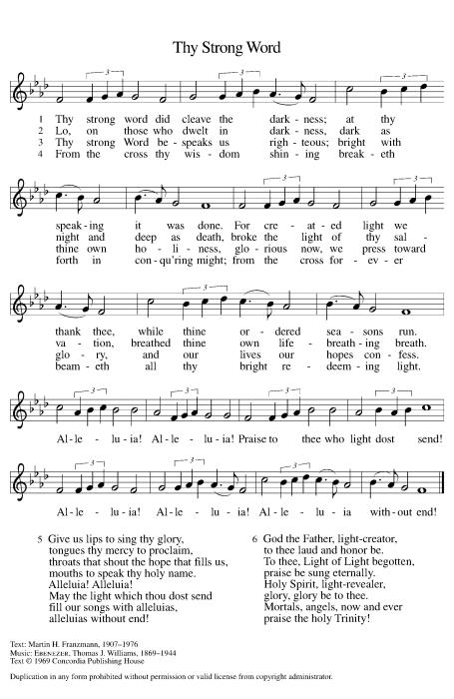

First Reading: Acts 4:5-12
A reading from Acts.
Peter and John had been arrested the previous day because they were proclaiming the news of the resurrection to the people. In today’s reading, Peter is filled with the Holy Spirit so that he can proclaim salvation in Jesus’ name to the religious authorities.
⁵The next day [the] rulers, elders, and scribes assembled in Jerusalem, ⁶with Annas the high priest, Caiaphas, John, and Alexander, and all who were of the high-priestly family. ⁷When they had made the prisoners stand in their midst, they inquired, “By what power or by what name did you do this?” ⁸Then Peter, filled with the Holy Spirit, said to them, “Rulers of the people and elders, ⁹if we are questioned today because of a good deed done to someone who was sick and are asked how this man has been healed, ¹⁰let it be known to all of you, and to all the people of Israel, that this man is standing before you in good health by the name of Jesus Christ of Nazareth, whom you crucified, whom God raised from the dead. ¹¹This Jesus is
‘the stone that was rejected by you, the builders;
it has become the cornerstone.’
¹²There is salvation in no one else, for there is no other name under heaven given among mortals by which we must be saved.”

The word of the Lord.
Thanks be to God.

Psalm: Psalm 23

Refrain: The Lord is my shepherd; I shall not be in want. (Ps. 23:1)
¹The Lord | is my shepherd;
I shall not | be in want.
²The Lord makes me lie down | in green pastures
and leads me be- | side still waters.
³You restore my | soul, O Lord,
and guide me along right pathways | for your name’s sake.
⁴Though I walk through the valley of the shadow of death, I shall | fear no evil;
for you are with me; your rod and your staff, they | comfort me.
R The Lord is my shepherd; I shall not be in want.
⁵You prepare a table before me in the presence | of my enemies;
you anoint my head with oil, and my cup is | running over.
⁶Surely goodness and mercy shall follow me all the days | of my life,
and I will dwell in the house of the | Lord forever.
R The Lord is my shepherd; I shall not be in want.
Second Reading: 1 John 3:16-24
A reading from 1 John.
Jesus’ death on our behalf is the clearest demonstration of divine love. This is the very love we share with others, not just through our words but especially through our deeds. In sharing such love we fulfill God’s commandments.
¹⁶We know love by this, that [Jesus Christ] laid down his life for us—and we ought to lay down our lives for one another. ¹⁷How does God’s love abide in anyone who has the world’s goods and sees a brother or sister in need and yet refuses help?
¹⁸Little children, let us love, not in word or speech, but in truth and action. ¹⁹And by this we will know that we are from the truth and will reassure our hearts before him ²⁰whenever our hearts condemn us; for God is greater than our hearts, and he knows everything. ²¹Beloved, if our hearts do not condemn us, we have boldness before God; ²²and we receive from him whatever we ask, because we obey his commandments and do what pleases him.
²³And this is his commandment, that we should believe in the name of his Son Jesus Christ and love one another, just as he has commanded us. ²⁴All who obey his commandments abide in him, and he abides in them. And by this we know that he abides in us, by the Spirit that he has given us.

The word of the Lord.
Thanks be to God.

Gospel Acclamation (ELW p. 151)

Alleluia. Lord, to whom shall we go?
You have the words of eternal life.
Alleluia.

Gospel: John 10:11-18

The holy gospel according to John.
Glory to you, O Lord.

In language that recalls the twenty-third psalm, Jesus describes himself as the shepherd who cares for his sheep. He is willing to die for them, and he is able to overcome death for them.

[Jesus said:] ¹¹“I am the good shepherd. The good shepherd lays down his life for the sheep. ¹²The hired hand, who is not the shepherd and does not own the sheep, sees the wolf coming and leaves the sheep and runs away—and the wolf snatches them and scatters them. ¹³The hired hand runs away because a hired hand does not care for the sheep. ¹⁴I am the good shepherd. I know my own and my own know me, ¹⁵just as the Father knows me and I know the Father. And I lay down my life for the sheep. ¹⁶I have other sheep that do not belong to this fold. I must bring them also, and they will listen to my voice. So there will be one flock, one shepherd. ¹⁷For this reason the Father loves me, because I lay down my life in order to take it up again. ¹⁸No one takes it from me, but I lay it down of my own accord. I have power to lay it down, and I have power to take it up again. I have received this command from my Father.”

The gospel of the Lord.
Praise to you, O Christ.

Children’s Sermon (ELW p. 151) - Pastor Jeremy Ullrich
Sermon (ELW p. 151) - Pastor Jeremy Ullrich
Hymn of the Day - We Come to You for Healing, Lord - ELW Hymn #617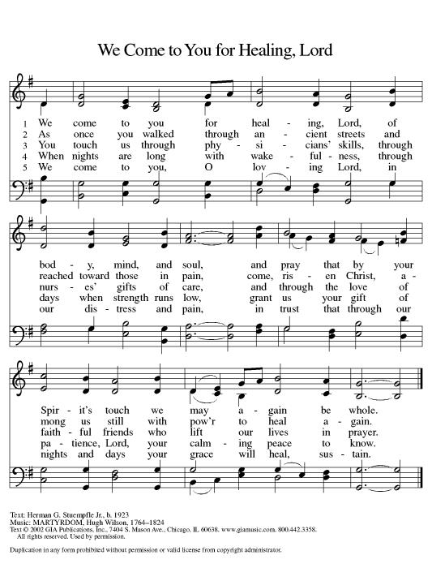

Nicene Creed (ELW p. 152)
We believe in one God,
the Father, the Almighty,
maker of heaven and earth,
of all that is, seen and unseen.
We believe in one Lord, Jesus Christ,
the only Son of God,
eternally begotten of the Father,
God from God, Light from Light,
true God from true God,
begotten, not made,
of one Being with the Father;
through him all things were made.
For us and for our salvation
he came down from heaven,
was incarnate of the Holy Spirit and the virgin Mary
and became truly human.
For our sake he was crucified under Pontius Pilate;
he suffered death and was buried.
On the third day he rose again
in accordance with the scriptures;
he ascended into heaven
and is seated at the right hand of the Father.
He will come again in glory to judge the living and the dead,
and his kingdom will have no end.
We believe in the Holy Spirit, the Lord, the giver of life,
who proceeds from the Father and the Son,*
who with the Father and the Son is worshiped and glorified,
who has spoken through the prophets.
We believe in one holy catholic and apostolic church.
We acknowledge one baptism for the forgiveness of sins.
We look for the resurrection of the dead,
and the life of the world to come. Amen.

*Or, “who proceeds from the Father.” The phrase “and the Son” is a later addition to the creed.

Prayers of Intercession
Rejoicing that Jesus is risen and love has triumphed over fear, let us pray for the church, the world, and all those in need of good news.

Shepherding God, gather your church whenever we wander from you and one another. Empower our church in ministries around the world to worship and serve alongside global companions as equal partners and coworkers in the gospel. God of grace,
hear our prayer.
Nurturing God, preserve the health of biomes and ecosystems. Inspire scientists, researchers, conservation organizations, and all people entrusted with the task of caring for creation, that we may be better stewards of the world around us. God of grace,
hear our prayer.
Almighty God, lead nations and communities to share resources, cooperate in solving conflicts, and listen to the wisdom of Indigenous peoples. Help all those with power to share it and to use such power for good. God of grace,
hear our prayer.
Loving God, protect the very young and the very old, those living without housing, victims of domestic abuse, and all who live with chronic illness or compromised immune systems. Guide communities to actively care for people who are vulnerable. God of grace,
hear our prayer.
Gracious God, help this and all communities of faith to listen for your voice. Call us away from things that distract us from following you. Invite us to more deeply love and serve people who are lonely, isolated, and on the margins. God of grace,
hear our prayer.
Living God, we give thanks for our ancestors in faith. Strengthen us to share the good news in our own day. God of grace,
hear our prayer.
Into your hands, most merciful God, we commend all for whom we pray, trusting in your abiding love; through Jesus Christ, our resurrected and living Lord.
Amen.

Peace (ELW p. 152)
The peace of Christ be with you always.
And also with you.

Offering (ELW p. 152)

Let the vineyards be fruitful, Lord,
and fill to the brim our cup of blessing.
Gather a harvest from the seeds that were sown,
that we may be fed with the bread of life.
Gather the hopes and the dreams of all;
unite them with the prayers we offer now.
Grace our table with your presence,
and give us a foretaste of the feast to come.

Offering Prayer (ELW p. 152)
Let us pray.
Blessed are you, O God, ruler of heaven and earth. Day by day you shower us with blessings. As you have raised us to new life in Christ, give us glad and generous hearts, ready to praise you and to respond to those in need, through Jesus Christ, our Savior and Lord. Amen.

Dialogue (ELW p. 152)
The Lord be with you.
And also with you.
Lift up your hearts.
We lift them to the Lord.
Let us give thanks to the Lord our God.
It is right to give our thanks and praise.

Preface (ELW p. 153)
It is indeed right, our duty and our joy,
that we should at all times and in all places
give thanks and praise to you, almighty and merciful God,
through our Savior Jesus Christ;
who on this day overcame death and the grave,
and by his glorious resurrection opened to us the way of everlasting life.
And so, with all the choirs of angels,
with the church on earth and the hosts of heaven,
we praise your name and join their unending hymn:

Holy, Holy, Holy (ELW p. 153)

Holy, holy, holy Lord,
Lord God of pow’r and might:
Heav’n and earth are full of your glory.
Hosanna in the highest.
Blessed is he who comes in the name of the Lord.
Hosanna in the highest.

Words of Institution (ELW p. 153)
In the night in which he was betrayed,
our Lord Jesus took bread, and gave thanks;
broke it, and gave it to his disciples, saying:
Take and eat; this is my body, given for you.
Do this for the remembrance of me.

Again, after supper, he took the cup, gave thanks,
and gave it for all to drink, saying:
This cup is the new covenant in my blood,
shed for you and for all people for the forgiveness of sin.
Do this for the remembrance of me.

Lord’s Prayer (ELW p. 154)
Lord, remember us in your kingdom and teach us to pray.
Our Father, who art in heaven,
hallowed be thy name,
thy kingdom come,
thy will be done,
on earth as it is in heaven.
Give us this day our daily bread;
and forgive us our trespasses,
as we forgive those
who trespass against us;
and lead us not into temptation,
but deliver us from evil.
For thine is the kingdom,
and the power, and the glory,
forever and ever. Amen.

Invitation to Communion (ELW p. 154)
Taste and see that the Lord is good.

Communion (ELW p. 154)
Lamb of God, you take away the sin of the world;
have mercy on us.
Lamb of God, you take away the sin of the world;
have mercy on us.
Lamb of God, you take away the sin of the world;
grant us peace, grant us peace.

Communion Hymn - All Who Hunger, Gather Gladly - ELW Hymn #461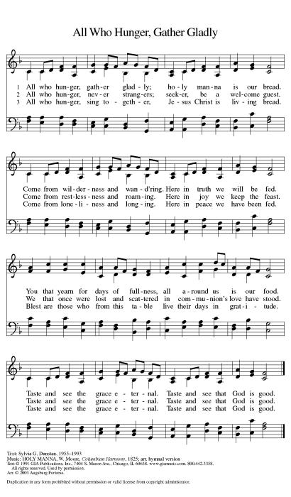

Prayer after Communion (ELW p. 155)
Let us pray.
We give you thanks, almighty God, that you have refreshed us through the healing power of this gift of life. In your mercy, strengthen us through this gift, in faith toward you and in fervent love toward one another; for the sake of Jesus Christ our Lord. Amen.

Blessing (ELW p. 155)
Almighty God, Father, ☩ Son, and Holy Spirit, bless you now and forever.
Amen.

Sending Song - All Hail the Power of Jesus’ Name! - ELW Hymn #634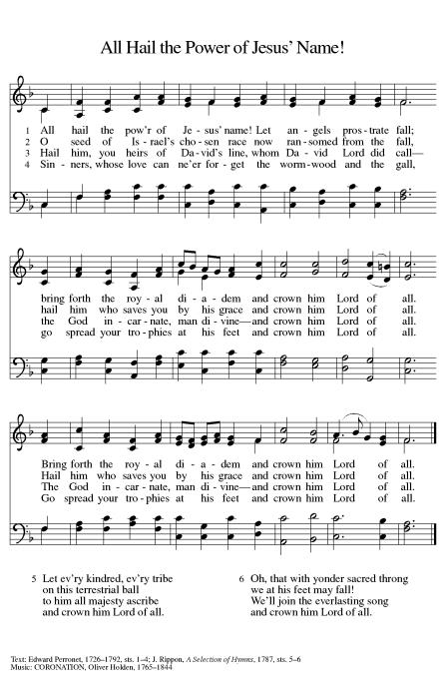

Dismissal (ELW p. 155)
Go in peace. Serve the Lord.
Thanks be to God.

From sundaysandseasons.com. Copyright © 2024 Augsburg Fortress. All rights reserved. Hymns available under One License A - 710028

OFFICIATING & SERVING - April 21
Pastor: Jeremy Ullrich Organist: Debra Caldwell
Pastor Asst. Weldon Kurtz
Communion Asst. Harold Kurtz
Lector: Lynn Stroud
Usher Captain: Tim Steglich
Ushers: Justin Young, Michael, Joey, and Travis Saverse
Greeters: Harold & Joan Kurtz
Altar Care: Robert & Dorothy Marwitz
Teller Captain: Pam Fleming
Teller: Darrell & April Marek
OFFICIATING & SERVING - April 28
Pastor: Jeremy Ullrich Organist: Debra Caldwell
Lector: Lynn Stroud
Usher Captain: Tim Steglich
Ushers: Justin Young, Michael, Joey, and Travis Saverse
Greeters: Harold & Joan Kurtz
Altar Care: Robert & Dorothy Marwitz
Teller Captain: Judy Gersbach
Teller: Darrell & April Marek
OFFICIATING & SERVING - May 5
Pastor: Jeremy Ullrich Organist: Debra Caldwell
Pastor Asst. Weldon Kurtz
Communion Asst. Don Bruggman
Lector: Jill Marwitz
Usher Captain: Lynn Friedrich
Ushers: Jimmy Gommert, Charles Hill, David Tschoerner, Dale Dawson, Lynn & Pat Stroud
Greeters: Weldon & Cedalia Kurtz
Altar Care: Mila Wegner & Pam Fleming
Teller Captain: Sharon Koonsen
Teller: Mona Smalley
OFFERING & ATTENDANCE
Worship Attendance Offering YTD
Mar 31 Easter 114 $4,272.00 $45,576.31
Apr 7 60 $4,129.00 $49,705.31
Apr 14 81 $2,615.00 $52,320.31
IN OUR PRAYERS
Garland Wentrcek Stanley Glaser Janie Barron Lange Eldon Lange
Celeste Gamrod Pansy Lange Janelle Janke Risa Steglich
Ruth and Ray Janke Gayle Bielss Sharon Randig Shelby Pagel
Darrell Kurtz(Twin Brother of Harold Kurtz) Imogene Morris
Andrea Griffith(co-worker of Evelyn Steglich) Paula Umberhagen
Monica Blane(Pastor Daniel Blane’s daughter) Erin Steglich’s Friend’s Dad-Mr. Hardy
James Chapman(Dorothy Marwitz’s Brother-in-law)
Jamie Fuller (Shirley Fisher’s Daughter’s Friend)
Josh Ramirez & Sheena Woods(Sharon Randig’s friends)
Jimmy Dubose-grandfather of Kendal & Jr Gersbach and Great-grandfather to Cayson & Barrett

FUTURE HAPPENINGS
Monday: Dominoes each Monday in TRC @ 2:00 pm
Wednesday: Men’s Bible Study each Wednesday in the TRC @ 7:30 am
Thursday: Piece Makers meet each Thursday in the TRC @ 1:00 pm
ANNOUNCEMENTS
Piecemakers Request
The Piecemakers have asked for any sewing, crocheting, knitting, and supplies for sewing quilts. This would include sewing machines, scissors, rotary cutters, fabric, thread, pins and needles or anything that pertains to quilting.
Pastoral Visits
We are encouraging those hospitalized, nursing home residents (or, their family members), and the homebound members and friends who wish to schedule an in-person pastoral visit or phone call to contact Pastor Jeremy Ullrich @ 979-421-3303 or the church office @ 254-527-3341.
NOTE: Pastor Ullrich will need to be listed as a “visitor of choice” in hospitals or nursing homes. This will need to be established by a family member.

Sunday School
Adult Sunday School is at 9:15am in the TRC
Youth Sunday School starts February 11 @9:30am.

Articles for the Newsletter
Please submit your articles for the monthly newsletter before the 19th of the month, as they are mailed out the following week. Thank you!

Men’s Bible Study
The Men’s Bible Study meets each Wednesday at 7:30am in the TRC.

Will-O-Bell Nursing Home Worship
Thank you to everyone who has been supporting the residents of our local nursing home! Through communion and a 30-minute hymn sing-along, please show these residents they are not forgotten by joining us on the first Wednesday of each month at 2pm in Granger and on the third Thursday of each month at 10AM in Bartlett. Please come and make a resident smile.

Live Stream Learning
St. John has purchased a camcorder to help with our live stream. We are looking for tech-inclined volunteers interested in testing out different settings. We will use an apprenticeship model for training, so you will have a mentor helping as long as you wish. For more information, contact the church office (254-527-3341).

Martha’s Circle Bible Study
Martha's Circle Bible Study is the 4th Wednesday of every month @ 10am, for more information contact Janice Atchison (254-721-8477).

Flag Donations
3x5 U.S. Flags with grommets are appreciated for our church. In memory of loved ones, you may donate flags, or make cash donations, at the church office. For further information contact Walt Saverse @ 254-770-8381, or contact the church office @ 254-527-3341.

Sisters in Christ Bible Study
The Sisters in Christ Bible study (Saturday Bible Study) is every 3rd Saturday of the month at 10am They are studying a new series titled “Fierce” by Jennifer Cowart. The study covers lesser known ladies in the Bible and the ways they changed the world by living into God’s calling.

Prayer Requests
When you make a prayer request for a non-member, please provide the church office with contact information so that we can send them a card. Thank you.

Congregation
I want to thank everyone for their continued prayers, words of encouragement, cards and love sent to me. My family at St. John is amazing, as you continue to lift me up in prayer. Thank you from the bottom of my heart for making my days brighter and easier. God Bless You All, Celeste Gamrod .

Youth Sunday School
Youth Sunday School every Sunday. Class will begin at 9:30am and end at 10:15am. Youth ages 3 through 12th grade are encouraged to attend. We will sing, hear a Bible story and work on crafts. There is a need for volunteers. Anyone who can help in any way, please text Sharon Randig at 512-713-4433.

Childcare for Pastor’s Children
My family is looking for childcare help. Specifically, we seek trustworthy and caring individuals to sit with the kids (7/5/3) for two to three hours while they watch their age-appropriate shows in our home. Our biggest needs are during the week, especially for Wednesday nights in Lent (Feb 14 to March 27). $20 per hour. Super friendly family dog. Please call or text your interest or potential leads at 979-421-3303. Thank you in advance for blessing my family! -Pastor Jeremy

Dominoes
Every Monday @ 2PM in the TRC– Domino games (42 and Straight)

Heart of Texas (HOT) Spring Gathering
The Spring Gathering will be held at Covenant Lutheran Church in Temple Texas on Saturday April 27, 2024 from 9 am to 1 pm. Registration forms are available in the TRC and are due April 1st. WELCA will cover the registration fees for those who attend. Please turn forms into the church office.

