ST. JOHN LUTHERAN CHURCH BARTLETT, TX
ELW Setting Four - Sunday, April 28, 2024
Fifth Sunday of Easter

Announcements
Prelude

Thanksgiving for Baptism (ELW p. 97)
In the name of the Father,
and of the ☩ Son,
and of the Holy Spirit.
Amen.
Joined to Christ in the waters of baptism,
we are clothed with God's mercy and forgiveness.
Let us give thanks for the gift of baptism.

We give you thanks, O God,
for in the beginning your Spirit moved over the waters
and by your Word you created the world,
calling forth life in which you took delight.

Through the waters of the flood you delivered Noah and his family.
Through the sea you led your people Israel from slavery into freedom.
At the river your Son was baptized by John and anointed with the Holy Spirit.
By water and your Word you claim us as daughters and sons,
making us heirs of your promise and servants of all.

We praise you for the gift of water that sustains life,
and above all we praise you for the gift of new life in Jesus Christ.
Shower us with your Spirit,
and renew our lives with your forgiveness, grace, and love.

To you be given honor and praise
through Jesus Christ our Lord
in the unity of the Holy Spirit, now and forever.
Amen.

Gathering Song - Let Us Ever Walk with Jesus - ELW Hymn #802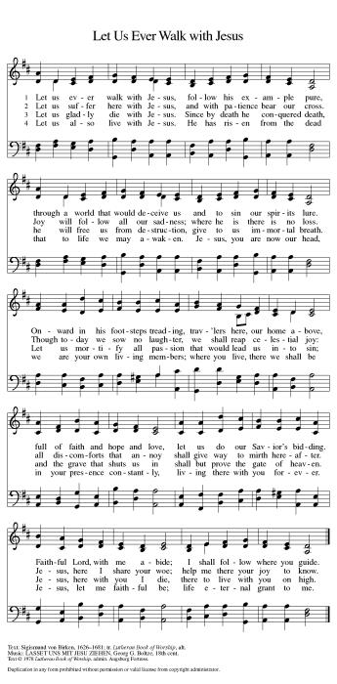

Greeting (ELW p. 147)
The grace of our Lord Jesus Christ, the love of God,
and the communion of the Holy Spirit be with you all.
And also with you.

Kyrie (ELW p. 147)
In peace, let us pray to the Lord.
Lord, have mercy.
For the peace from above,
and for our salvation,
let us pray to the Lord.
Lord, have mercy.
For the peace of the whole world,
for the well-being of the Church of God,
and for the unity of all,
let us pray to the Lord.
Lord, have mercy.
For this holy house,
and for all who offer here their worship and praise,
let us pray to the Lord.
Lord, have mercy.
Help, save, comfort, and defend us, gracious Lord.
Amen.

Canticle of Praise (ELW p. 148)
Glory to God in the highest,
and peace to God’s people on earth.
Lord God, heavenly King, almighty God and Father,
we worship you, we give you thanks,
we praise you for your glory.
Lord Jesus Christ,
only Son of the Father, Lord God, Lamb of God,
you take away the sin of the world: have mercy on us;
you are seated at the right hand of the Father:
receive our prayer. For you alone are the Holy One,
you alone are the Lord, you alone are the Most High,
Jesus Christ, with the Holy Spirit,
in the glory of God the Father. Amen.

Prayer of the Day (ELW p. 150)
Let us pray.
O God, you give us your Son as the vine apart from whom we cannot live. Nourish our life in his resurrection, that we may bear the fruit of love and know the fullness of your joy, through Jesus Christ, our Savior and Lord, who lives and reigns with you and the Holy Spirit, one God, now and forever. Amen.

Song - Holy Spirit, Ever Dwelling - ELW Hymn #582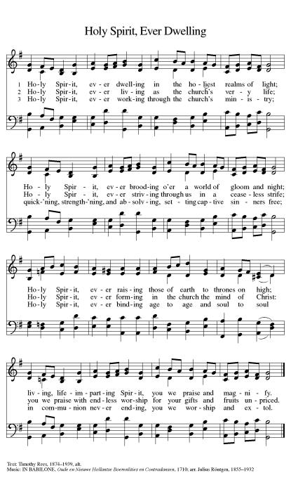

First Reading: Acts 8:26-40
A reading from Acts.
Led by the Spirit, Philip encounters an Ethiopian official who is returning to his African home after having been to Jerusalem to worship. Philip uses their encounter to proclaim the gospel to him. Upon coming to faith in Jesus, he is baptized by Philip.
²⁶An angel of the Lord said to Philip, “Get up and go toward the south to the road that goes down from Jerusalem to Gaza.” (This is a wilderness road.) ²⁷So he got up and went. Now there was an Ethiopian eunuch, a court official of the Candace, queen of the Ethiopians, in charge of her entire treasury. He had come to Jerusalem to worship ²⁸and was returning home; seated in his chariot, he was reading the prophet Isaiah. ²⁹Then the Spirit said to Philip, “Go over to this chariot and join it.” ³⁰So Philip ran up to it and heard him reading the prophet Isaiah. He asked, “Do you understand what you are reading?” ³¹He replied, “How can I, unless someone guides me?” And he invited Philip to get in and sit beside him. ³²Now the passage of the scripture that he was reading was this:
“Like a sheep he was led to the slaughter,
and like a lamb silent before its shearer,
so he does not open his mouth.
³³In his humiliation justice was denied him.
Who can describe his generation?
For his life is taken away from the earth.”
³⁴The eunuch asked Philip, “About whom, may I ask you, does the prophet say this, about himself or about someone else?” ³⁵Then Philip began to speak, and starting with this scripture, he proclaimed to him the good news about Jesus. ³⁶As they were going along the road, they came to some water; and the eunuch said, “Look, here is water! What is to prevent me from being baptized?” ³⁸He commanded the chariot to stop, and both of them, Philip and the eunuch, went down into the water, and Philip baptized him. ³⁹When they came up out of the water, the Spirit of the Lord snatched Philip away; the eunuch saw him no more, and went on his way rejoicing. ⁴⁰But Philip found himself at Azotus, and as he was passing through the region, he proclaimed the good news to all the towns until he came to Caesarea.

Word of God, word of life.
Thanks be to God.

Psalm: Psalm 22:25-31
Refrain: All the ends of the earth shall remember and turn to the Lord. (Ps. 22:27)
²⁵From you comes my praise in the | great assembly;
I will perform my vows in the sight of those who | fear the Lord.
²⁶The poor shall eat | and be satisfied,
Let those who seek the Lord give praise! May your hearts | live forever!
²⁷All the ends of the earth shall remember and turn | to the Lord;
all the families of nations shall bow | before God.
²⁸For dominion belongs | to the Lord,
who rules o- | ver the nations.
R All the ends of the earth shall remember and turn to the Lord.
²⁹Indeed, all who sleep in the earth shall bow | down in worship;
all who go down to the dust, though they be dead, shall kneel be- | fore the Lord.
³⁰Their descendants shall | serve the Lord,
whom they shall proclaim to genera- | tions to come.
³¹They shall proclaim God’s deliverance to a people | yet unborn,
saying to them, “The | Lord has acted!”
R All the ends of the earth shall remember and turn to the Lord.

Second Reading: 1 John 4:7-21
A reading from 1 John.
We love God and others because God first loved us. We cannot say we love God, whom we have not seen, while hating fellow Christians, whom we regularly see. Love toward God is to be matched by love toward others because the essence of God is love.
⁷Beloved, let us love one another, because love is from God; everyone who loves is born of God and knows God. ⁸Whoever does not love does not know God, for God is love. ⁹God’s love was revealed among us in this way: God sent his only Son into the world so that we might live through him. ¹⁰In this is love, not that we loved God but that he loved us and sent his Son to be the atoning sacrifice for our sins. ¹¹Beloved, since God loved us so much, we also ought to love one another. ¹²No one has ever seen God; if we love one another, God lives in us, and his love is perfected in us.
¹³By this we know that we abide in him and he in us, because he has given us of his Spirit. ¹⁴And we have seen and do testify that the Father has sent his Son as the Savior of the world. ¹⁵God abides in those who confess that Jesus is the Son of God, and they abide in God. ¹⁶So we have known and believe the love that God has for us.
God is love, and those who abide in love abide in God, and God abides in them. ¹⁷Love has been perfected among us in this: that we may have boldness on the day of judgment, because as he is, so are we in this world. ¹⁸There is no fear in love, but perfect love casts out fear; for fear has to do with punishment, and whoever fears has not reached perfection in love. ¹⁹We love because he first loved us. ²⁰Those who say, “I love God,” and hate their brothers or sisters, are liars; for those who do not love a brother or sister whom they have seen, cannot love God whom they have not seen. ²¹The commandment we have from him is this: those who love God must love their brothers and sisters also.

Word of God, word of life.
Thanks be to God.

Gospel Acclamation (ELW p. 151)
Alleluia. Lord, to whom shall we go?
You have the words of eternal life.
Alleluia.

Gospel: John 15:1-8

The holy gospel according to John.
Glory to you, O Lord.

On the night of his arrest, Jesus taught his disciples about the relationship they would have with him. Those who abide in his word and love bear fruit, for apart from him, they can do nothing.
[Jesus said:] ¹“I am the true vine, and my Father is the vinegrower. ²He removes every branch in me that bears no fruit. Every branch that bears fruit he prunes to make it bear more fruit. ³You have already been cleansed by the word that I have spoken to you. ⁴Abide in me as I abide in you. Just as the branch cannot bear fruit by itself unless it abides in the vine, neither can you unless you abide in me. ⁵I am the vine, you are the branches. Those who abide in me and I in them bear much fruit, because apart from me you can do nothing. ⁶Whoever does not abide in me is thrown away like a branch and withers; such branches are gathered, thrown into the fire, and burned. ⁷If you abide in me, and my words abide in you, ask for whatever you wish, and it will be done for you. ⁸My Father is glorified by this, that you bear much fruit and become my disciples.”

The gospel of the Lord.
Praise to you, O Christ.

Children’s Sermon (ELW p. 151) - Pastor Jeremy Ullrich
Sermon (ELW p. 151) - Pastor Jeremy Ullrich
Hymn of the Day - Spread, Oh Spread, Almighty Word - ELW Hymn #663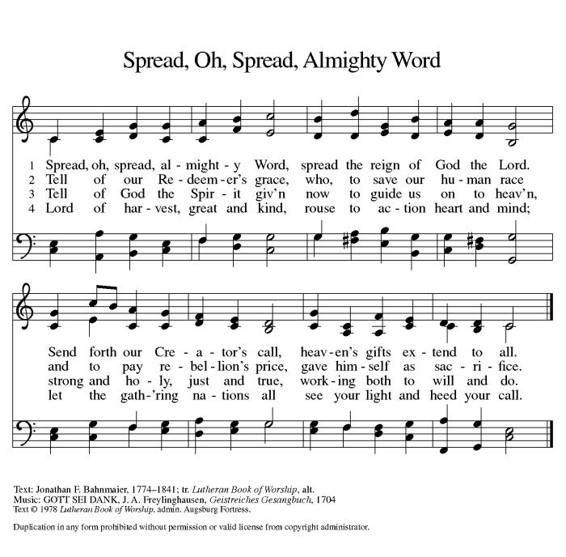

Apostles’ Creed (ELW p. 152)

I believe in God, the Father almighty,
creator of heaven and earth.
I believe in Jesus Christ, God’s only Son, our Lord,
who was conceived by the Holy Spirit,
born of the virgin Mary,
suffered under Pontius Pilate,
was crucified, died, and was buried;
he descended to the dead.*
On the third day he rose again;
he ascended into heaven,
he is seated at the right hand of the Father,
and he will come to judge the living and the dead.
I believe in the Holy Spirit,
the holy catholic church,
the communion of saints,
the forgiveness of sins,
the resurrection of the body,
and the life everlasting. Amen.

*Or, “he descended into hell,” another translation of this text in widespread use.
Prayers of Intercession
Rejoicing that Jesus is risen and love has triumphed over fear, let us pray for the church, the world, and all those in need of good news.

.We pray for the church around the world, for all ministers, and for the mission of the gospel. Keep all the newly baptized and confirmed in your care. Cleanse our hearts with your word and help us to abide in you always. God of grace,
hear our prayer.
For the well-being of the earth and of all created things: for rivers and lakes, streams and estuaries, melting glaciers and polluted waters. Renew the face of the earth and shower us with your goodness. God of grace,
hear our prayer.
For the nations and all those in authority: for local, state, and national leaders, for elected representatives at every level, and for international organizations, that justice and peace may reign. God of grace,
hear our prayer.
For all those in need: for any experiencing homelessness or unemployment, for those fleeing from oppression or seeking asylum, and for all who are ill or suffering. God of grace,
hear our prayer.
For this congregation: for the caring ministries of this faith community, for all who visit and minister to one another, for all who take communion to homes or care centers, and for all who seek to share your love with the world. God of grace,
hear our prayer.
With thanksgiving for the saints who rest from their labors. Help us, like them, to bear much fruit and to become your disciples, and at the last, bring us to that heavenly banquet where all will feast together at your table. God of grace,
hear our prayer.
Into your hands, most merciful God, we commend all for whom we pray, trusting in your abiding love; through Jesus Christ, our resurrected and living Lord.
Amen.

Peace (ELW p. 152)
The peace of Christ be with you always.
And also with you.

Offering (ELW p. 152)

Create in me a clean heart, O God,
and renew a right spirit within me.
Cast me not away from your presence,
and take not your Holy Spirit from me.
Restore to me the joy of your salvation,
and uphold me with your free Spirit.

Offering Prayer (ELW p. 152)
Let us pray.
Blessed are you, O God, ruler of heaven and earth. Day by day you shower us with blessings. As you have raised us to new life in Christ, give us glad and generous hearts, ready to praise you and to respond to those in need, through Jesus Christ, our Savior and Lord. Amen.

Lord’s Prayer (ELW p. 154)
Lord, remember us in your kingdom and teach us to pray.
Our Father, who art in heaven,
hallowed be thy name,
thy kingdom come,
thy will be done,
on earth as it is in heaven.
Give us this day our daily bread;
and forgive us our trespasses,
as we forgive those
who trespass against us;
and lead us not into temptation,
but deliver us from evil.
For thine is the kingdom,
and the power, and the glory,
forever and ever. Amen.

Blessing (ELW p. 155)
The Lord bless you and keep you.
The Lord’s face shine on you with grace and mercy.
The Lord look upon you with favor and ☩ give you peace.
Amen.

Sending Song - Lord, Dismiss Us with Your Blessing - ELW Hymn #545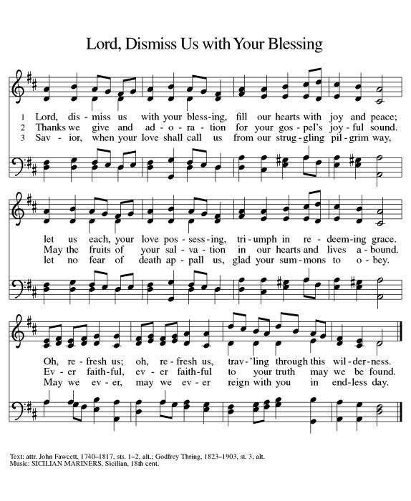

Dismissal (ELW p. 155)
Go in peace. Share the good news.
Thanks be to God.

From sundaysandseasons.com. Copyright © 2024 Augsburg Fortress. All rights reserved. Hymns available under One License A - 710028.

OFFICIATING & SERVING - April 28
Pastor: Jeremy Ullrich Organist: Debra Caldwell
Lector: Lynn Stroud
Usher Captain: Tim Steglich
Ushers: Justin Young, Michael, Joey, and Travis Saverse
Greeters: Harold & Joan Kurtz
Altar Care: Robert & Dorothy Marwitz
Teller Captain: Judy Gersbach
Teller: Darrell & April Marek
OFFICIATING & SERVING - May 5
Pastor: Jeremy Ullrich Organist: Debra Caldwell
Pastor Asst. Weldon Kurtz
Communion Asst. Don Bruggman
Lector: Jill Marwitz
Usher Captain: Lynn Friedrich
Ushers: Jimmy Gommert, Charles Hill, David Tschoerner, Dale Dawson, Lynn & Pat Stroud
Greeters: Weldon & Cedalia Kurtz
Altar Care: Mila Wegner & Pam Fleming
Teller Captain: Sharon Koonsen
Teller: Mona Smalley
OFFICIATING & SERVING - May 12
Pastor: Jeremy Ullrich Organist: Debra Caldwell
Lector: Jill Marwitz
Usher Captain: Lynn Friedrich
Ushers: Jimmy Gommert, Charles Hill, David Tschoerner, Dale Dawson, Lynn & Pat Stroud
Greeters: Weldon & Cedalia Kurtz
Altar Care: Mila Wegner & Pam Fleming
Teller Captain: Sharon Koonsen
Teller: Mona Smalley
OFFERING & ATTENDANCE
Worship Attendance Offering YTD
Mar 31 Easter 114 $4,272.00 $45,576.31
Apr 7 60 $4,129.00 $49,705.31
Apr 14 81 $2,615.00 $52,320.31
Apr 21 57 $2,692.00 $55,012.31
IN OUR PRAYERS
Garland Wentrcek Stanley Glaser Janie Barron Lange Eldon Lange
Celeste Gamrod Pansy Lange Janelle Janke Risa Steglich
Ruth and Ray Janke Gayle Bielss Sharon Randig Shelby Pagel
Darrell Kurtz(Twin Brother of Harold Kurtz) Imogene Morris
Andrea Griffith(co-worker of Evelyn Steglich) Paula Umberhagen
Monica Blane(Pastor Daniel Blane’s daughter) Mr. Hardy (Erin Steglich’s Friend’s Dad)
James Chapman(Dorothy Marwitz’s Brother-in-law)
Jamie Fuller (Shirley Fisher’s Daughter’s Friend)
Josh Ramirez & Sheena Woods(Sharon Randig’s friends)
Jimmy Dubose-grandfather of Kendal & Jr Gersbach and Great-grandfather to Cayson & Barrett
FUTURE HAPPENINGS
Monday: Dominoes each Monday in TRC @ 2:00 pm
Wednesday: Men’s Bible Study each Wednesday in the TRC @ 7:30 am
Thursday: Piece Makers meet each Thursday in the TRC @ 1:00 pm
ANNOUNCEMENTS
Piecemakers Request
The Piecemakers have asked for any sewing, crocheting, knitting, and supplies for sewing quilts. This would include sewing machines, scissors, rotary cutters, fabric, thread, pins and needles or anything that pertains to quilting.
Pastoral Visits
We are encouraging those hospitalized, nursing home residents (or, their family members), and the homebound members and friends who wish to schedule an in-person pastoral visit or phone call to contact Pastor Jeremy Ullrich @ 979-421-3303 or the church office @ 254-527-3341.
NOTE: Pastor Ullrich will need to be listed as a “visitor of choice” in hospitals or nursing homes. This will need to be established by a family member.

Sunday School
Adult Sunday School is at 9:15am in the TRC
Youth Sunday School starts February 11 @9:30am.

Articles for the Newsletter
Please submit your articles for the monthly newsletter before the 19th of the month, as they are mailed out the following week. Thank you!

Men’s Bible Study
The Men’s Bible Study meets each Wednesday at 7:30am in the TRC.

Will-O-Bell Nursing Home Worship
Thank you to everyone who has been supporting the residents of our local nursing home! Through communion and a 30-minute hymn sing-along, please show these residents they are not forgotten by joining us on the first Wednesday of each month at 2pm in Granger and on the third Thursday of each month at 10AM in Bartlett. Please come and make a resident smile.
Live Stream Learning
St. John has purchased a camcorder to help with our live stream. We are looking for tech-inclined volunteers interested in testing out different settings. We will use an apprenticeship model for training, so you will have a mentor helping as long as you wish. For more information, contact the church office (254-527-3341).

Martha’s Circle Bible Study
Martha's Circle Bible Study is the 4th Wednesday of every month @ 10am, for more information contact Janice Atchison (254-721-8477).

Flag Donations
3x5 U.S. Flags with grommets are appreciated for our church. In memory of loved ones, you may donate flags, or make cash donations, at the church office. For further information contact Walt Saverse @ 254-770-8381, or contact the church office @ 254-527-3341.

Sisters in Christ Bible Study
The Sisters in Christ Bible study (Saturday Bible Study) is every 3rd Saturday of the month at 10am They are studying a new series titled “Fierce” by Jennifer Cowart. The study covers lesser known ladies in the Bible and the ways they changed the world by living into God’s calling.

Prayer Requests
When you make a prayer request for a non-member, please provide the church office with contact information so that we can send them a card. Thank you.

Congregation
I want to thank everyone for their continued prayers, words of encouragement, cards and love sent to me. My family at St. John is amazing, as you continue to lift me up in prayer. Thank you from the bottom of my heart for making my days brighter and easier. God Bless You All, Celeste Gamrod .

Youth Sunday School
Youth Sunday School every Sunday. Class will begin at 9:30am and end at 10:15am. Youth ages 3 through 12th grade are encouraged to attend. We will sing, hear a Bible story and work on crafts. There is a need for volunteers. Anyone who can help in any way, please text Sharon Randig at 512-713-4433.

Childcare for Pastor’s Children
My family is looking for childcare help. Specifically, we seek trustworthy and caring individuals to sit with the kids (7/5/3) for two to three hours while they watch their age-appropriate shows in our home. Our biggest needs are during the week, especially for Wednesday nights in Lent (Feb 14 to March 27). $20 per hour. Super friendly family dog. Please call or text your interest or potential leads at 979-421-3303. Thank you in advance for blessing my family! -Pastor Jeremy

Dominoes
Every Monday @ 2PM in the TRC– Domino games (42 and Straight)

